

**Name: Muhammad Fahad**

**Sap ID: 37125**

**Section: BSCS-5A**

**Course: Advance computer programming**

**Assignment#1**

Github link code file:

1. **Composite Relationship:**

* In a composite relationship, one class contains another class as a part. The contained class cannot exist independently outside the container class. If the container class is destroyed, the contained class is also destroyed.
* It represents a "whole-part" or "has-a" relationship.
* A common example is a Car class containing Engine, Wheels, and Seats as its parts.

Main.java

public class Main {  
 public static void main(String[] args) {  
 Car myCar = new Car();  
 myCar.startCar();  
 myCar.drive();  
 myCar.park();  
 myCar.occupySeat(2, "Fahad");  
 myCar.occupySeat(0, "Mehboob");  
 myCar.vacateSeat(2);  
 myCar.occupySeat(3, "zaibi");  
  
 }  
}

Car.java

class Car {  
 private Engine engine;  
 private Wheel[] wheels;  
 private Seat[] seats;  
  
 public Car() {  
 engine = new Engine();  
 wheels = new Wheel[4];  
 seats = new Seat[5];  
  
 for (int i = 0; i < 4; i++) {  
 wheels[i] = new Wheel();  
 }  
  
 for (int i = 0; i < 5; i++) {  
 seats[i] = new Seat();  
 }  
 }  
  
 public void startCar() {  
 engine.start();  
 System.*out*.println("Car started");  
 }  
  
 public void drive() {  
 for (Wheel wheel : wheels) {  
 wheel.rotate();  
 }  
 System.*out*.println("Car is moving");  
 }  
  
 public void park() {  
 System.*out*.println("Car is parked");  
 }  
  
 public void occupySeat(int seatNumber, String personName) {  
 if (seatNumber >= 0 && seatNumber < seats.length) {  
 seats[seatNumber].sit(personName);  
 } else {  
 System.*out*.println("Invalid seat number");  
 }  
 }  
  
 public void vacateSeat(int seatNumber) {  
 if (seatNumber >= 0 && seatNumber < seats.length) {  
 seats[seatNumber].getUp();  
 } else {  
 System.*out*.println("Invalid seat number");  
 }  
 }  
}

Seat.java

class Seat {  
 private String occupant;  
  
 public Seat() {  
 occupant = null;  
 }  
  
 public void sit(String personName) {  
 occupant = personName;  
 System.*out*.println(personName + " is sitting in the seat");  
 }  
  
 public void getUp() {  
 if (occupant != null) {  
 System.*out*.println(occupant + " got up from the seat");  
 occupant = null;  
 }  
 }  
}

Wheal.java

class Wheel {  
 public void rotate() {  
 System.*out*.println("Wheel rotating");  
 }  
}

Engine.java

class Engine {  
 public void start() {  
 System.*out*.println("Engine started");  
 }  
}

output

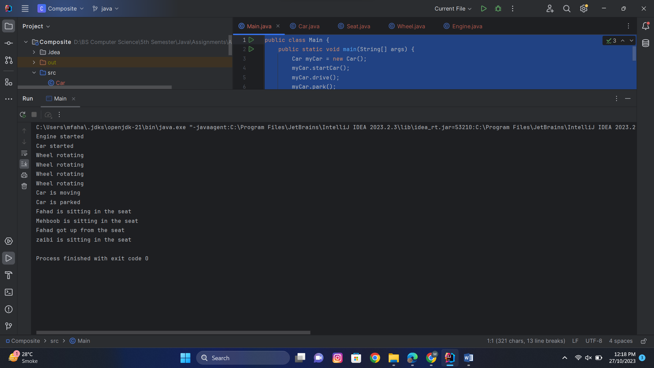

1. **Aggregation Relationship:**

* In an aggregation relationship, one class is associated with another class, but the associated class can exist independently. It represents a "whole-part" or "has-a" relationship, just like composite, but with a key difference: the contained class has its own lifecycle and can be shared among multiple containers.
* When the container is destroyed, the contained class is not necessarily destroyed.
* A common example is a University class containing multiple Department classes.

Main.java

public class Main {  
 public static void main(String[] args) {  
 University myUniversity = new University(5);  
  
 Department csDepartment = new Department("Computer Science");  
 Department eeDepartment = new Department("Electrical Engineering");  
  
 myUniversity.addDepartment(csDepartment);  
 myUniversity.addDepartment(eeDepartment);  
  
 myUniversity.displayDepartments();  
 }  
}

University.java

class University {  
 private Department[] departments;  
 private int departmentCount;  
  
 public University(int maxDepartments) {  
 departments = new Department[maxDepartments];  
 departmentCount = 0;  
 }  
  
 public void addDepartment(Department department) {  
 if (departmentCount < departments.length) {  
 departments[departmentCount] = department;  
 departmentCount++;  
 } else {  
 System.*out*.println("Cannot add more departments. The university is at full capacity.");  
 }  
 }  
  
 public void displayDepartments() {  
 System.*out*.println("Riphah International University Departments:");  
 for (int i = 0; i < departmentCount; i++) {  
 System.*out*.println(departments[i].getName());  
 }  
 }  
}

Department.java

class Department {  
 private String name;  
  
 public Department(String name) {  
 this.name = name;  
 }  
  
 public String getName() {  
 return name;  
 }  
}

Output:

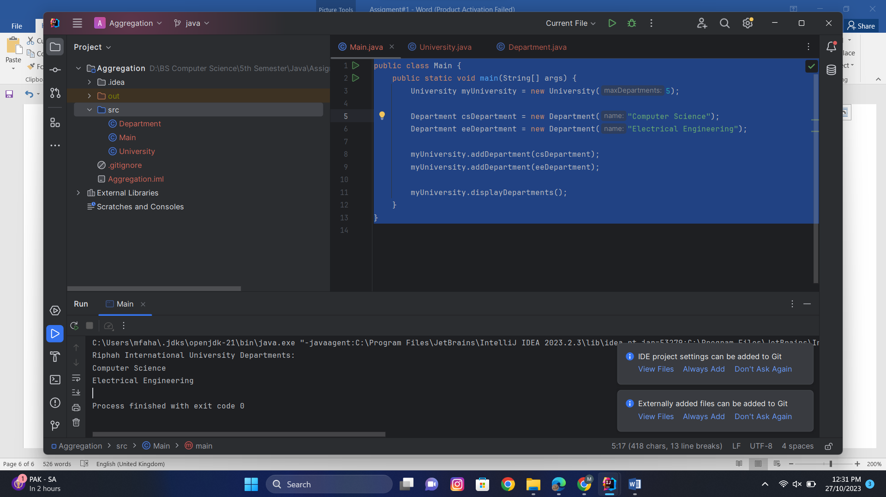

1. **Association Relationship:**

* In an association relationship, two classes are related, but they are not part of each other. It represents a more general relationship where objects of one class are aware of the objects of another class.
* The relationship can be one-way or two-way. For example, a Teacher class may be associated with a Student class, but the reverse is also true. Both classes can exist independently and have their own lifecycles.
* Associations can have multiplicity, indicating how many objects of one class can be associated with objects of another class.

Main.java

public class Main {  
 public static void main(String[] args) {  
 Member member1 = new Member("Fahad");  
 Member member2 = new Member("Mehboob");  
 Library library = new Library();  
 library.checkOutBook(member1, "Introduction to Java");  
 library.checkOutBook(member2, "Programming in Python");  
 }  
}

Member.java

class Member {  
 private String name;  
 public Member(String name) {  
 this.name = name;  
 }  
 public String getName() {  
 return name;  
 }  
 public void borrowBook(String bookTitle) {  
 System.*out*.println(name + " has borrowed the book: " + bookTitle);  
 }  
}

Library.java

class Library {  
 public void checkOutBook(Member member, String bookTitle) {  
 System.*out*.println("Library: Checking out the book: " + bookTitle);  
 member.borrowBook(bookTitle);  
 }  
}

Output:

